**UCLA EPSS Departmental Exam Proposals**

*Jaahnavee Venkatraman*

Proposal 1: Statistical Estimates of Rock-Free Lunar Regolith Thickness from Diviner

**1 Motivation**

The lunar regolith is our primary source of lunar geological and geophysical information (Fa and Wieczorek, 2012; Hayne et al., 2017; Hörz et al., 1991; Shkuratov and Bondarenko, 2001; National Aeronautics and Space Administration, 1994). Recent evidence also suggests that the lunar regolith may harbor valuable resources, including volatile ices, near the lunar poles (Colaprete et al., 2010; Fisher et al., 2017; Hayne et al., 2015; Li et al., 2018; Rubanenko et al., 2019). Understanding how thick the lunar regolith is i.e. to what depth below the Moon's surface the soil is fine-grained and rock-free, is key to advancing these scientific efforts, particularly in light of the Artemis program and its science objectives (National Aeronautics and Space Administration, 2020). The presence of boulder fields on the Moon's surface and buried beneath the regolith fines have historically been an obstacle for lunar landings (Apollo 11 mission report, 1969). Rock abundance (RA) measurements from the Lunar Reconnaissance Orbiter (LRO) Diviner Lunar Radiometer Experiment provide a means to begin quantifying the distribution of these boulders on the surface. Diviner-derived RA is the fraction of surface area covered by boulders in a single Diviner pixel (Bandfield et al., 2011). Combined with data from fresh impacts and our knowledge of lunar geology, this can inform us about the distribution of subsurface consolidated rock in the lunar highlands versus maria using regolith thickness estimates.

**2 Background**

There have been prior efforts to characterize the approximate thickness of the lunar regolith. Results from Apollo seismic data (Hörz et al., 1991), crater morphology studies (Quaide and Oberbeck, 1968; Bart et al., 2011), radar data (Shkuratov and Bondarenko, 2011; Fa and Wieczorek, 2012), and crater size frequency distribution statistics (Wilcox et al., 2005) estimate the thickness of the lunar regolith to be between 2 and 17 m. It is important to note that all of these estimates fall within ranges due to differences in impact gardening, and the resulting differences in regolith overturn across the Moon (Quaide and Oberbeck, 1968).

Comparing the lunar highlands and mare is one approach to effectively capture differences in regolith thickness across the lunar surface and is the method we adopt in our work. It is important to note that the geology and composition of the lunar regolith is still under debate. Some define it as the low cohesion material formed by repetitive bombardment of the lunar surface (Shoemaker and Morris, 1970), separate from the underlying larger debris or rock. Others hypothesize that the fine material is likely interspersed with coarser-grained material, suggesting the possibility of an ambiguous ‘transition layer’ or ‘megaregolith’ (Oberbeck et al., 1973). We do not attempt to define the megaregolith in the present work. We are primarily concerned with rock detectable by Diviner and regolith that is rock-free.

Differences between the geology of the mare and highlands regolith will affect their respective thicknesses. It has been shown that there is a well-defined deposit of basalts beneath the mare regolith that stems from past lunar volcanism (Wilhelms et al., 1987). We expect the resulting differences in exposure age to have a direct effect on the regolith thickness in those regions. The lunar highlands having been pulverized from accumulated impacts are geologically more complex than the mare (Cintala and Mcbride, 1995). Seismic measurements point to the presence of highland impact breccia from sufficiently heated ejecta that cemented beneath the regolith but above larger rock (Hörz et al., 1991). The evidence presented here demonstrates the importance of comparing the lunar highlands and mare to effectively capture differences in regolith thickness across the lunar surface.

**3 Current Progress**

In the present work, we calculate rock-free regolith thickness statistically, using the LRO Diviner Lunar Radiometer (Paige et al., 2010) RA estimates from cold spot craters, which are visibly fresh impact craters surrounded by a large region of reduced nighttime temperatures (Bandfield et al., 2014). Since consolidated rock has a higher thermal inertia than fine-grained regolith, surface temperatures derived from Diviner measurements provide a means to understand physical properties such as RA on the lunar surface (Bandfield et al., 2011). Using this method, Diviner is able to detect rocks larger than 1 m in diameter. Fig. 1 illustrates the potential utility of surface RA measurements for probing subsurface material. Larger craters will naturally excavate deeper into the lunar surface. It is expected that small impact craters will excavate only regolith, while larger craters will excavate more consolidated rock detectable by Diviner (Fig. 1). We therefore expect to be able to measure lunar regolith thickness as the depth at which these craters excavate consolidated rock detectable by Diviner.

Fig. 1. Schematic of penetration depths and corresponding ejecta for a small crater and large crater, assuming the uppermost lunar surface layers from Hörz et al. (1991).

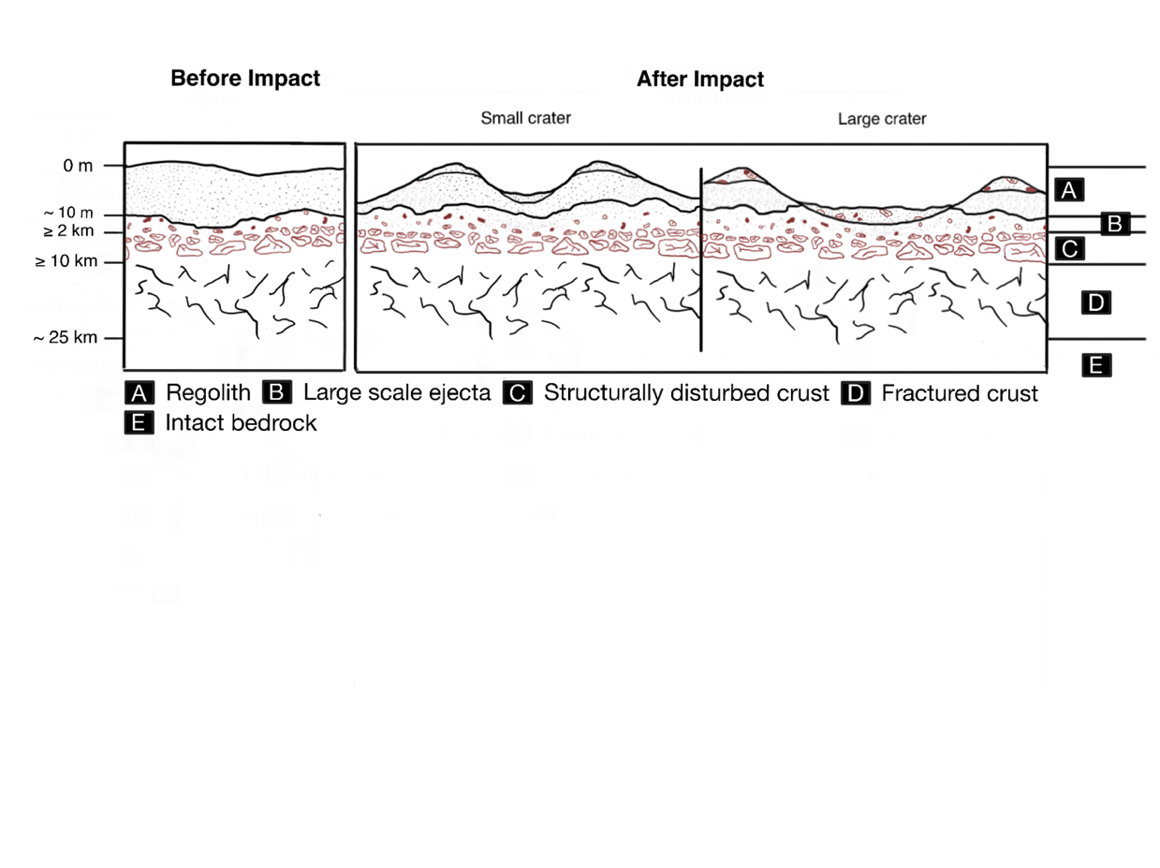

RA signatures have, however, been shown to fade over time (Ghent et al., 2014). Basilevsky et al. (2013) have also shown that the median survival time of meter-sized boulders on the rims of smaller craters on the Moon's surface is between just 40 and 80 Ma. Thus, focusing on fresh, young craters is of particular importance. Cold spots on the Moon provide us with the ability to constrain our database of craters to ones that are fresh and young. Williams et al. (2018) have shown that smaller cold spots around lunar craters persist for ~100 ka to 1 Ma, and therefore point to fresh, young impact craters with an enduring RA signature. Using the LRO Diviner Lunar Radiometer RA estimates from cold spot craters, we can statistically estimate rock-free regolith thickness.

**3.1 Normalized rock abundance**

For the present study we used an updated version (Venkatraman et al., 2022) of the Williams et al. (2018) cold spot dataset to find the centers and diameters of 2282 cold spot craters, ranging from 43 m to 2.3 km in diameter, equatorward of 50 $°$ latitude. We identified the center of each cold spot crater in both LROC NAC images and the Diviner 128 pixels per degree (240 m per pixel at the equator) improved global RA maps (Bandfield et al., 2011; Williams et al., 2017; Powell et al., 2022), as illustrated in Fig. 2. Most debris ejected by an impact crater falls within one crater diameter from the rim (Melosh, 1989). We therefore calculated the value of maximum and mean RA for the crater interior and surrounding ejecta within three radii from the center of that crater (Fig. 2). We use normalized Diviner RA (NRA) to distinguish ejecta rock values from the background regolith (all regolith away from the ejecta). While background regolith RA values are normally distributed, ejecta values are not (Ghent et al., 2014). Ejecta RA distributions are typically right-skewed and cannot be meaningfully represented by Gaussian summary statistics like the mean RA (Ghent et al., 2014). To effectively capture the right skew of the RA distribution for each crater, we calculate NRA as RAmax - RAmean of the region within three radii of the crater center. This is simply a heuristic method of capturing the skewness of a distribution by incorporating the distribution maxima. This statistic can be refined in future studies with the availability of more data (Behrens et al., 2004; Sohn et al., 2005). Our crater diameters for this study are right-skewed, following a power law distribution, with approximately 97% having diameters less than 500 m (Fig. 3).

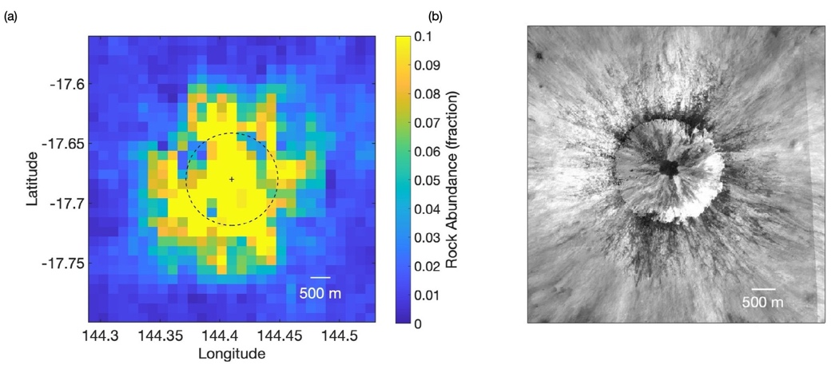

Fig. 2. (a) Example of Diviner derived RA for a 2.3 km diameter cold spot crater located at 4.079 S, 151.682 E. The black dashed line represents the rim of the crater centered at ’+’. (b) LROC NAC (Robinson et al., 2010; Robinson, 2010; Humm et al., 2016; Mahanti et al., 2016) Mosaic of images M125984243RE, M1222726789RE, and M1222726789LE corresponding to subfigure (a). Both images have a horizontal and vertical extend of three crater radii.

**3.2 Excavation depth**

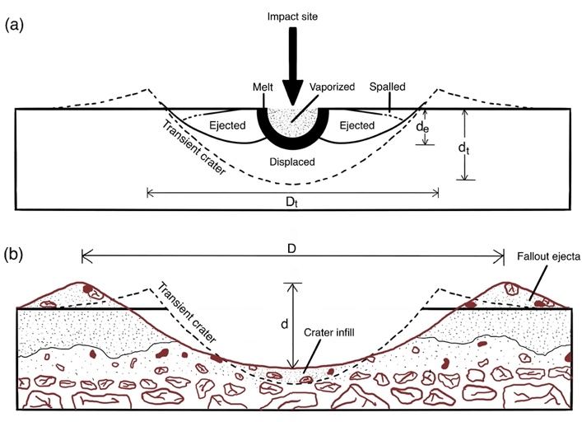

Fig. 4. (a) Shows a schematic of crater modification and movement of material during the formation of a typical small, simple crater (from Melosh (1989), Fig. 6.8, p. 238). (b) Shows the difference between the dimensions and nature of excavated material of transient and final crater boundaries post gravity-dominated collapse. Adapted from Grieve (1987).

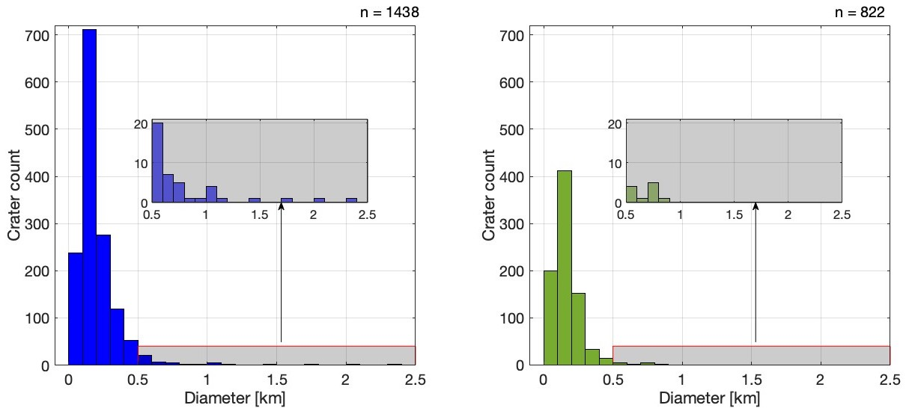

Fig. 3. Distribution of diameters for all cold spot craters in our RA dataset, for the highlands (left) and mare (right). Bin width of the histograms is 0.1 km. The inset plots show the tail-end of the distributions to highlight that simple cold spot craters at larger diameters occur less frequently in our dataset.

There are numerous processes that tend to affect the depth of small, strength-dominated craters, including ejection of crater material, displacement of material out of the crater deforming adjacent rocks, and the formation of a brief transient crater (Fig. 4a). The apparent depths (d) of these young, small, strength-dominated craters are 0.2 times their diameters (D) (Fig. 4b) which can be written as:

$d=0.2 D$ [citation 42]

Below a diameter of approximately 130 m however, the d/D ratio gradually decreases due to gravity dominated collapse of smaller, weaker crater walls (Stopar et al., 2017). What we are truly interested in is depth of excavation (de) (Fig. 4a) as opposed to apparent depth of the crater (d) (Fig. 4b). Melosh (1989) indicates that depth of excavation of simple craters with a diameter < 15 km is 10% of the diameter of the transient crater (Dt), which is 84% of the apparent diameter of the crater (D) yielding the following:

$d_{e}≈0.1 D_{t}$ [citation 38]

$D_{t}=0.84 D$ [citation 38]

$⇒d_{e}≈\left(0.84\right)\left(0.1\right)D=0.084 D$

Using these estimates, we get a depth of excavation equal to 8.4% of the apparent diameter of a small, simple crater.

**4 Results**

Our dataset has a much lower density of cold spot craters for diameters > 500 m than diameters < 500 m (Fig. 3, 5, 6). To see trends within smaller diameter ranges, and separate out diameters > 500 m where there is less data (n = 45), we compare NRA distributions by diameter (Fig. 6). This also allows us to see differences between the mare and highlands regions as crater diameter increases.

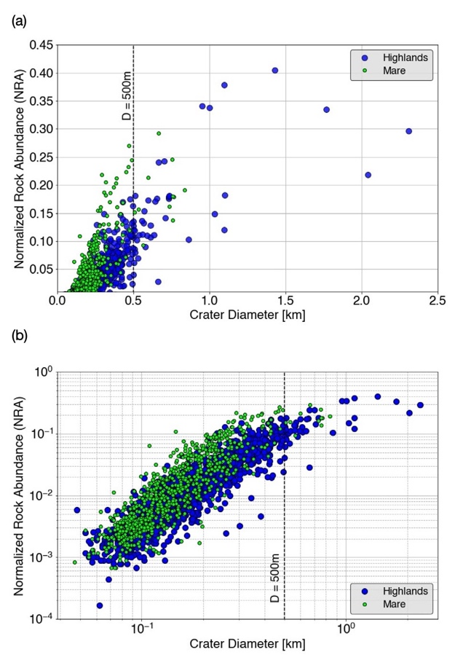

Fig. 5. Log-log scatterplot of cold spot crater diameter against NRA for the lunar mare and highlands.

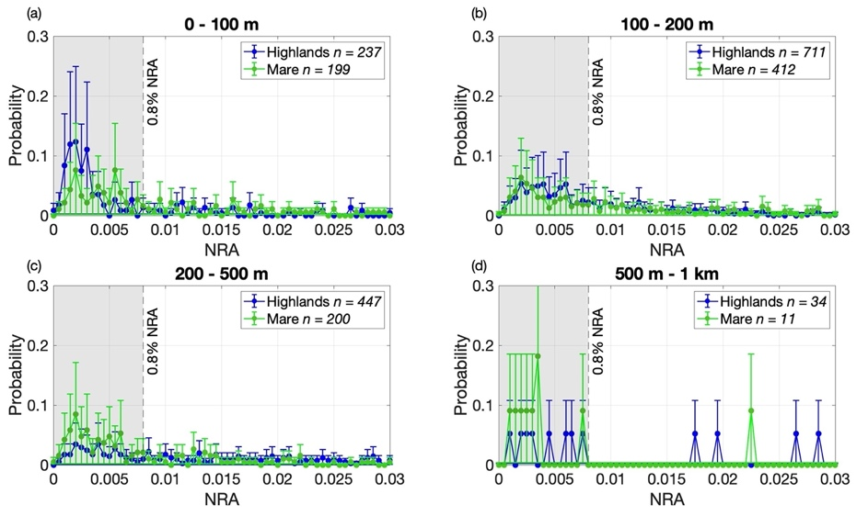

Fig. 6. NRA distributions by diameter for the mare and highlands: (a) 0–100 m, (b) 100–200 m, (c) 200–500 m, and (d) 500 m–1 km. Plots have a bin width of 0.05% NRA, with error bars representing the 95% confidence interval. The dashed black line represents our selected threshold for rockiness fraction, which we define as the probability that a given crater has an NRA value greater than 0.8%. Our NRA values extend out to 8% but we have only included values up to 3% for the sake of clarity.

**4.1 Threshold selection and rockiness fraction**

From Fig. 6a, b, and c, we see that majority craters have NRA < 0.8%. Our approach for identifying rocky craters requires choosing a ’rockiness’ decision threshold, below which craters are considered not rocky and above which they are considered rocky. A threshold of 0.8% NRA is therefore selected, and we define the probability that a given crater has an NRA value greater than 0.8% as the rockiness fraction $P\left(NRA≥0.8\%\right)$. This threshold can be refined in future studies with the availability of higher resolution data (Behrens et al., 2004; Sohn et al., 2005).

**4.2 Mare and highlands depths**

Plotting the rockiness fraction against crater diameter and excavation depth gives us slightly more discernible differences between the mare and the highlands (Fig. 7). The rockiness fractions for both the mare and highlands fit well with a Logistic Sigmoid function, typically used in statistics and machine learning to model how the probability of an event (a binary, dependent variable) might be affected by one or more explanatory variables (Cramer, 2004). If half the craters in a particular diameter bin are rocky (rockiness fraction $≥$ 0.5), we consider this to be an indication of rock excavation detectable by Diviner. The results show that 50% of craters are rocky at a diameter of around 123 m in the mare, and 141 m in the highlands. In accordance with Melosh (1989), these correspond to excavation depths of around 10 and 12 m respectively. Lunar mare craters seem, on average, to become rocky at slightly shallowerdepths than those on the highlands. Using maximum excavation depth estimations from Sharpton (2014), we get 3 m average rock-free regolith thickness in the mare, and 4 m in the highlands. Both models give us regolith thickness estimates that are within the range of other previous estimates (Fa and Wieczorek, 2012; Horz et al., 1991; Shkuratov and Bondarenko, 2001; Quaide and Oberbeck, 1968; Bart et al., 2011; Wilcox et al., 2005; Shoemaker and Morris, 1970) which is significant in that our approach to estimating regolith thickness differs from previous ones, while producing results consistent with them.

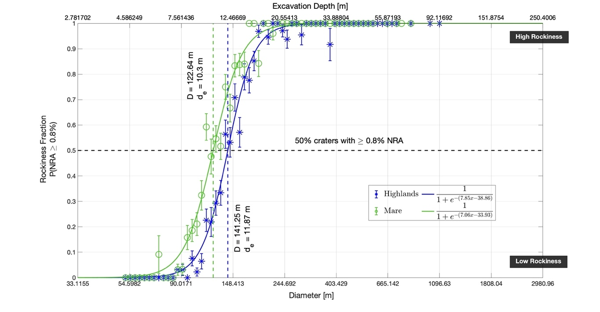

Fig. 7. Rockiness fraction by crater diameter (semi-logged along diameter, with log-space diameter binning) and excavation depth for the lunar mare and highlands. Each green and blue marker represents P(NRA $≥$ 0.8%) for each diameter bin in the mare and highlands respectively. The green and blue solid curves are Sigmoid fits for those regions. The error bars represent the 95% confidence interval of the rockiness fraction.

**5 Discussion**

Although there is evidence of a difference between the mare and highlands excavation depth estimates, we still do not completely understand the geology of the regolith-bedrock interface in either region. For instance, there is still debate as to whether a megaregolith or paleoregolith might exist, and if it's interspersed with finer regolith or completely buried beneath it. The presence of a megaregolith or shock-lithified breccia boulders could pose a challenge to regolith thickness estimates from Diviner. Detected rock could potentially include highly friable breccia thought to have been formed from regolith crystallization upon impact (Muehlberger et al., 1973; Schmitt, 1973). Fig. 5. in our results shows a relatively continuous distribution of NRA across diameter, indicating that a distinct and completely buried transition layer probably does not exist. Regardless, we expect friable breccia to have a lower thermal inertia than coherent rock (Elder et al., 2019), and therefore not significantly affect our results.

The presence of impact melt deposits in small, simple impact craters in the lunar highlands that either partly or completely bury rocks (Plescia and Cintala, 2012), could also

impact regolith thickness estimates from Diviner. Even so, these melt deposits are rare, and unlikely to significantly affect our results.

Our excavation depth estimates are unique values for both the mare and highlands regions. It is worth noting that interpreting these results in terms of a single regolith thickness can be problematic. Firstly, regolith thickness estimates are not only varied across techniques, but also spatially within a local area on the lunar surface (Wilcox et al., 2005; Wilhelms and with, 1987). Secondly, we must rely on existing excavation depth models (Melosh, 1989) to estimate these thicknesses. Sharpton (2014) has proposed a new model based on higher resolution LROC images showing crater deformation that suggests a depth of excavation less than or equal to 3% of the diameter of the transient crater. Using Sharpton's results would give us a depth of excavation of 2.52% of the apparent diameter of a small, simple crater. Melosh's model (Melosh, 1989) gives us regolith thickness estimates that are more than three times those of Sharpton's. However, both models give us estimates that are within the range of other previous studies (Fa and Wieczorek, 2012; Horz et al., 1991; Shkuratov and Bondarenko, 2001; Quaide and Oberbeck, 1968; Bart et al., 2011; Wilcox et al., 2005; Shoemaker and Morris, 1970).

Proposal 2: Improved Modeling of Polar Hydrogen Abundances Obtained by the Kaguya Gamma-Ray Spectrometer

**1 Introduction**

Hydrogen and other volatile reservoirs on the Moon have long been of interest to lunar scientists. There have been numerous measurements from orbital remote sensing of volatile abundances, specifically water ice, in permanently shadowed regions (PSRs) at the moon’s poles (citations). However, the spatial distribution of ice is not very well constrained. In the past, neutron spectrometry (NS) and gamma-ray spectrometry (GRS) have proven useful for detection of volatiles on airless bodies (citations). With greater depth sensitivity than infrared or spectral reflectance measurements (citations), neutron and gamma-ray spectrometry can tell us about the spatial and depth-dependence of hydrogen, and thereby water ice, in PSRs (citations).

The mechanism of neutron and gamma-ray hydrogen detection is as follows: airless bodies are exposed to a continuous stream of galactic cosmic rays (fig. 3), which are primarily high-energy protons. When they hit the lunar surface, the rays interact with the nuclei of various elements generating fast, high-energy, spallation neutrons (> 0.5 MeV) (citation). Once these neutrons moderate to epithermal energies (0.5 eV to 0.5 MeV) through various scattering processes, the most efficient mechanism to continue losing their energy is through elastic scattering with hydrogen nuclei, leading to a decrease in epithermal neutron fluxes detectable by NS (citation). At thermal energies (< 0.5 eV), this moderation process can be intercepted with neutron capture by a hydrogen nucleus, leading to characteristic gamma-ray emission at 2223 keV detectable by GRS (citation).

Owing to the sensitivity of epithermal neutrons to hydrogen (citation), water ice is most commonly mapped using epithermal neutron fluxes derived from NS data. Feldman et al. (1998, 2000a, 2001) and later Lawrence et al. (2006) modeled the epithermal neutron flux from the Lunar Prospector Neutron Spectrometer (LP-NS) (citation), predicting average polar hydrogen abundances of 100 - 150 ppm at a depth of 10 $±$ 5 cm beneath dry lunar soil. More recently, Lawrence et al. (2022) presented a new lunar hydrogen abundance map including corrections for rare-earth element variations, estimating the average global lunar hydrogen abundance to be $\sim$ 47 ppm.

The elemental abundances of various oxides and trace elements, such as FeO and Th, have been successfully modeled using the Lunar Prospector Gamma-Ray Spectrometer (LP-GRS) and the Selenological and Engineering Explorer (SELENE) Kaguya Gamma-Ray Spectrometer (KGRS) (citation). However, GRS hydrogen detection is more challenging (citation). GRS indirectly detects hydrogen by sensing characteristic 2223 keV gamma-rays emitted during capture of thermal neutrons by hydrogen nuclei to form deuterium (citation), making GRS less popular as a tool to map water ice. In addition, the 2223 keV hydrogen peak is heavily obscured by the doppler-broadened 2211 keV aluminum and 2230 keV sulfur inelastic scattering peaks (fig. 1). Even so, Feldman et al. (2000a) attempted to use LP-GRS measurements in combination with LP-NS thermal, epithermal, and fast neutron fluxes to map polar hydrogen deposits on the moon. They note, however, that the spectral resolution of the LP-NS Bismuth Germanate (BGO) scintillator was not sufficient to resolve the deuterium gamma ray line from surrounding peaks (citation).

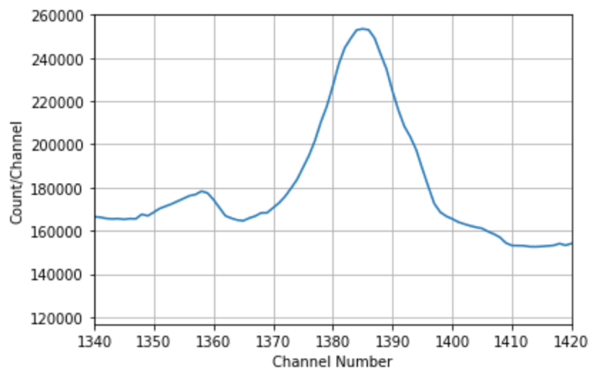

Fig. 1. KGRS Al, S, H emission spectra. Need a better labelled image that matches spectra in the literature.

Prior to the launch of SELENE (citation), Kobayashi et al. (2000) predicted that KGRS would reasonably be able to detect water ice of at least 1000 ppm, if homogenously distributed in the top layer of regolith, up to 30 g/cm2 (citation). However, no maps of water ice have been successfully produced from either direct KGRS measurements, or forward modeling of the KGRS hydrogen peak. Since semiconductor detectors like KGRS have better energy resolution than scintillation detectors like LP-GRS (citation), using KGRS data will allow us to better constrain lunar hydrogen abundance estimates. Here, we present an improved model for determining hydrogen abundances in conjunction with data from KGRS and propose future directions for the project.

**2 KGRS Instrument and Data**

KGRS used a large-volume high-purity germanium (HPGe) crystal cryocooled to below 90 K as its primary detector. The detector was split into a high- and low-gain amplifier spectrums covering 0.15 – 3.2 MeV and 0.15 to 13 MeV respectively. At 100 km altitude, its spatial resolution was 130 – 134 km for 1.5 MeV with an isotropic gamma response function. Anisotropy in the response function occurred at lower frequencies, giving a spatial resolution of 105 – 130 km for 0.2 MeV (citation). Pulse heights from both amplifiers were digitized with an output of 8192 channels each. KGRS had a fixed accumulation interval of 17 s (citation). Data collection occurred in three intervals or ‘periods’ as shown in table 1. During periods 1 and 3, the instrument was pointed at the lunar surface. During period 2 it was pointed towards deep space to measure background gamma-rays from the spacecraft.

|  |  |  |  |  |  |
| --- | --- | --- | --- | --- | --- |
| **Interval** | **Start Date** | **End Date** | **# of Spectra** | **Energy resolution** | **Nominal altitude** |
| Period 1 | 2007-12-14 | 2008-02-16 | 264544 | 6 – 10 keV | 100 km |
| Period 2 | 2008-07-04 | 2008-12-15 | 541419 | 12 – 18 keV | 100 km |
| Period 3 | 2009-02-10 | 2009-05-28 | 527736 | 6 – 7 keV | 30 x 50 km |

Table : Summary of KGRS spectrum data collection.

**3 Proposed Modeling**

Various methods have been used to model hydrogen detection from the lunar surface. Feldman et al. (1998) used LP-NS data in combination with High-Energy Nucleon-Meson Transport Code (HETC) (citation) to model the production and high energy transport (> 10 MeV) of neutrons, and the One Dimensional Diffusion Accelerated Neutron Particle Code (ONEDANT) (citation) to model the transport of lower-energy neutrons (< 10 MeV). More recently, the Monte Carlo N-Particle Transport (MCNPX) code has been used extensively (citations). The three-dimensional radiation transport code is designed to simulate the pathway of various particles through a range of energies (citation). It has the ability to therefore model the process of hydrogen detection starting from protons hitting the lunar surface, neutron transport, and final gamma-ray detection by the GRS (citation).

MCNPX has been used to model hydrogen using LP-NS data, and other elemental abundances using LP-GRS data. Using these methods as a benchmark, we want to use MCNPX to model hydrogen using KGRS data.

**3.1 GCR Flux**

The first step is to model the differential $4π$ GCR flux hitting the surface of the moon for which we use the energy distribution given in McKinney et al. (2006):

|  |  |
| --- | --- |
| $$g\left(T, ϕ\right)=A∙\frac{T\left(T+2E_{o}\right){\left(T+m+ϕ\right)}^{γ}}{\left(T+ϕ\right)\left(T+2E_{o}+ϕ\right)}$$ | (1) |

where $g\left(T, ϕ\right)$ has units of particles/cm2 s MeV. (MeV/nucleon) is the particle kinetic energy per nucleon, which from current literature, ranges from 101 to 104 (citation). $E_{o}=mc^{2}$ is the rest energy of the nucleon in MeV. GCR comprises of $\sim$ 90% protons and $\sim$ 9% alpha particles (citation) which dictates the rest of the equation (1) parameter values shown in Table 2.

|  |  |  |  |  |
| --- | --- | --- | --- | --- |
| Particle | A | a (MeV)* | b (MeV-1)* |  |
| Proton | 1.24e6 | 780 | 2.5e-4 | 2.65 |
| Alpha | 2.26e5 | 660 | 1.4e-4 | 2.77 |

Table 2: Parameters for the differential flux equation (1) taken from Lal (1985).  
 *m = a exp(-bT)

$ϕ$ (MV) is the solar modulation potential that accounts for the particle energy loss as it traverses the heliosphere (citation). Since the GCR flux reaching a planetary surface is modulated primarily by the solar cycle (citation), we can use neutron counts from the Earth-based stations (citation) at the time KGRS collected data to determine a baseline for solar modulation. Using the equation from Castagnoli and Lal (1980) and data from Earth-based neutron monitors, we find the average particle fluxes for periods 1 and 3 (fig. 2). This integrated area under the flux curve is used as input into MCNPX and will vary depending on the neutron monitor used (citations).

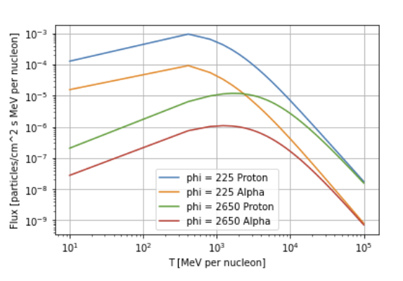

Fig. 2. Proton and alpha differential fluxes for McMurdo (225 MV) and Thule (2650 MV) neutron stations during periods 1 and 3 of the KGRS mission.

**3.2 Lunar Surface Interaction and Transport**

Fig. 3. Neutron interactions in the Lunar surface. Small blue circles are neutrons (fast > epithermal > thermal in descending order of energy). Large grey circles denote nuclei. White halos denote an excited energy state. Grey dashed halo denotes an unstable ground state. Curvy arrows indicate gamma-ray emission.

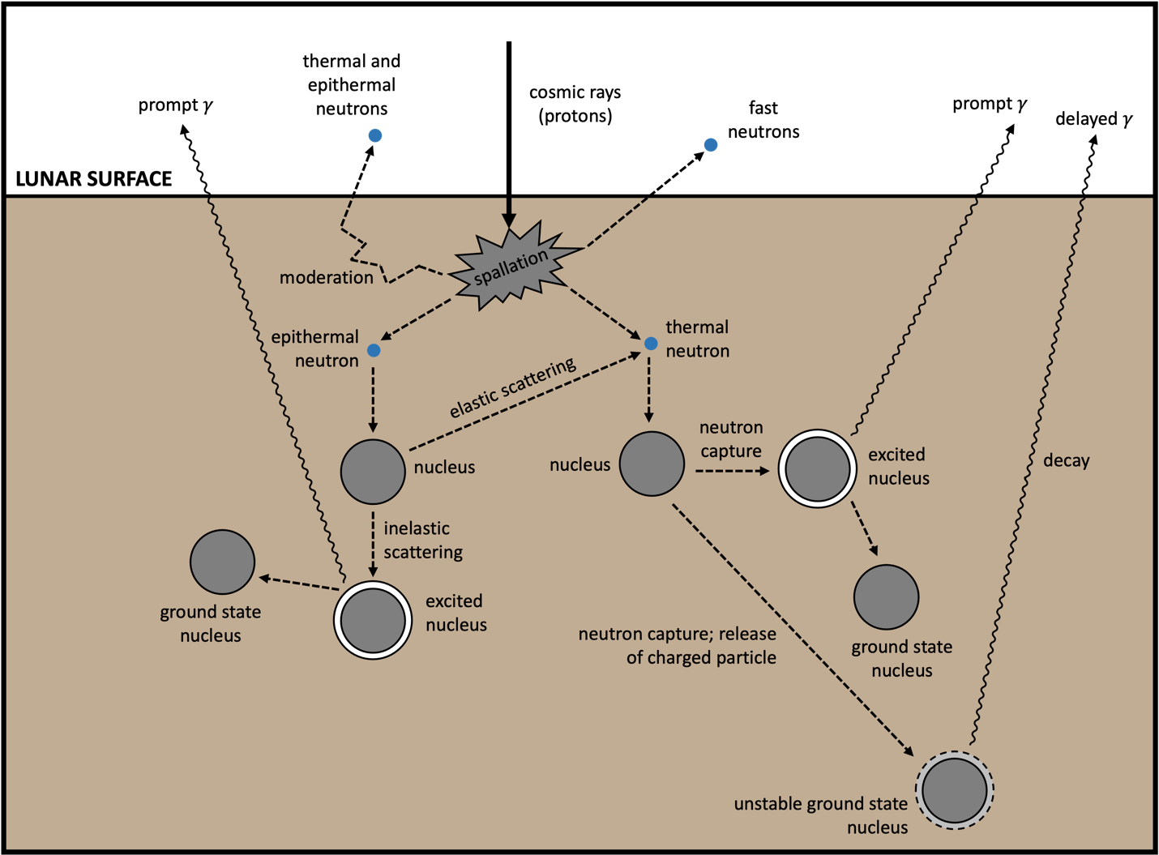

Neutrons can interact with the Lunar surface in various ways as shown in fig. 3. These interactions are dependent on the energy of the incoming neutron. (a) Elastic scattering involves collisions where part of the kinetic energy of the incoming neutron is transferred to the impacted nucleus. The neutron does not leave the recoil nucleus in an excited energy state. It is a common mechanism by which epithermal neutrons moderate to thermal neutrons when interacting with light nuclei like hydrogen. It is a relevant process for NS detections of hydrogen. (b) Inelastic scattering occurs when the incoming neutron has sufficient kinetic energy (> 100 keV for heavy nuclei and a few MeV for light nuclei) to put the recoil nucleus in an excited energy state. These excited nuclei can reach their stable ground states through release of a characteristic prompt gamma ray. (c) Absorption by the regolith occurs through neutron capture by the target nucleus when the neutron has sufficiently low energy. The recoil nucleus either ends up in an excited energy state andreleases a prompt gamma ray to deexcite, or a charged particle reaction occurs leading to an unstable ground state nucleus that can decay to release delayed gamma rays. For GRS hydrogen detection, we are interested in the former since thermal neutron capture by hydrogen (fig. 4) ultimately leads to the release of a prompt 2223 keV gamma ray in the reaction 1H(n,)2H.

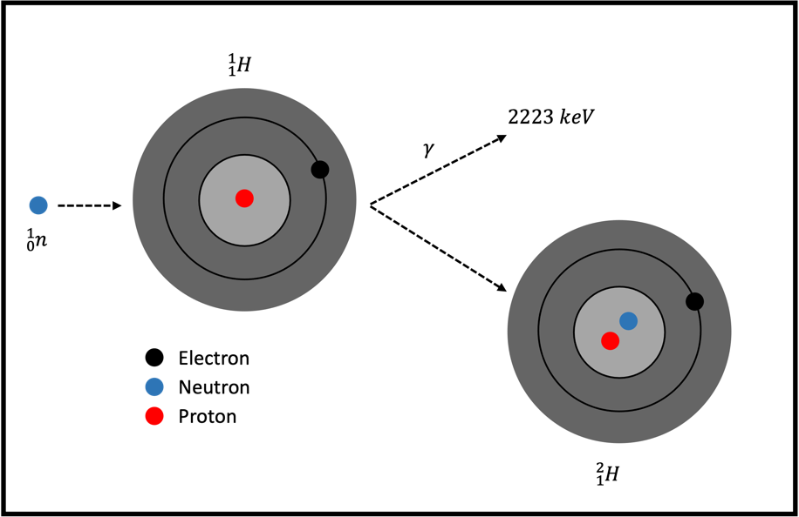

Fig. 4. Neutron capture of hydrogen.

**There are a few material and geometric considerations that need to be taken into account for our modeling. First, thermal neutrons can be captured by other elements as well. This means that the final GRS counts might not be indicative of all the hydrogen present. Assuming a primarily ferroan anorthosite (FAN) soil (citations), other elements that can capture thermal neutrons are Be-7 and B-10. Therefore, we must account for the neutron absorption cross-sections of these nuclei.**

**3.3 Transport of Neutrons to Detector**

**Our calculations also need to account for the movement of neutrons in a planetary gravitational field. To model the transport of neutrons to the detector, we need to include the angular response of neutrons coming off the lunar surface. Our model also needs to account for factors such as spacecraft motion, and the curved, ballistic trajectories of low-energy neutrons. We also need to use the modeled detector efficiencies from Lawrence et al. (2002) for the LP-NS 3He proportional counters.**

**Eke et al. (2015) points out that the relief of craters has an impact on the lunar neutron flux reaching the detector. MCNPX assumes that the neutron flux from a point on the lunar surface is proportional to the cosmic ray flux at that point. However, when accounting for negative topography features, we must consider how much of the feature is actually in view of the detector. This will impact the final neutron count detected by the GRS. Talk about raytracing?**

**3.4 Sulphur and Aluminum Peaks**

**In the final GRS spectrum, the 2223 keV hydrogen peak is heavily obscured by the two doppler-broadened 2211 keV 27Al and 2230 keV 32S inelastic scattering peaks (fig. 1). In order to model hydrogen effectively, it is useful to look at the neighboring spectra to model the entire curve. At 2211 keV, the reaction occurring is 27Al(n,n’)27Al, while at 2230 keV, the reaction occurring is 32S(n,n’)32S. In order to send 27Al and 32S into their excited states for prompt gamma emission, they must inelastically scatter an incoming epithermal neutron.**

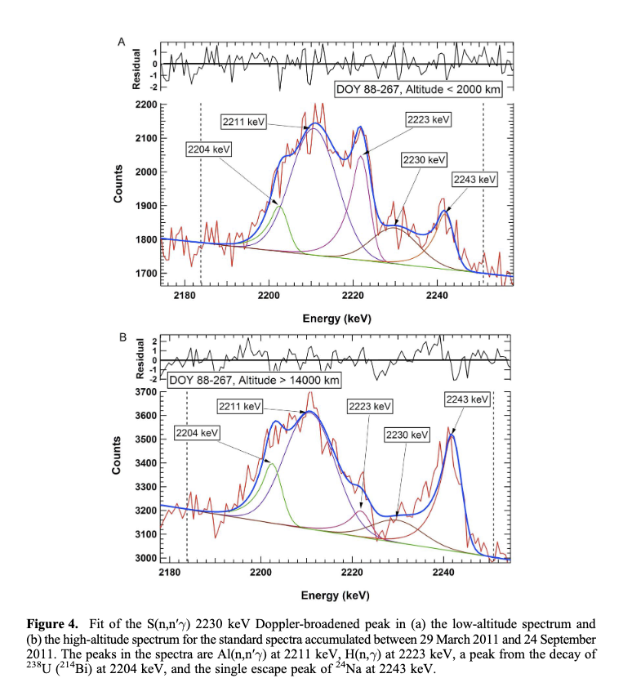

* Are there any models for single escape / double escape peaks like for S and Al? Show the breakdown of peaks within the spectrum (fig. 5)
* Combining the peaks + noise?

**4 Expected Results**

* What are the expected outcomes?
* How do the results contribute to the field?

**5 Discussion**

* Potential challenges / limitations
* Future directions of the project: machine learning?
  + If we’re able to successfully forward model the hydrogen peak and surrounding Al and S peaks, we can effectively calculate what the ppm of hydrogen needs to be in the upper 5 - 15 cm of lunar soil to generate a spectrum like the one we see in the KGRS data. MCNPX also allows us to generate multiple spectra under various scenarios: at multiple latitudes, under different solar flux conditions, and varying the soil composition.
  + From this we can use
* Conclusion

**Middle of Summer what can we do (5 months)**

* MCNPX fairly standard calculations of radioactive elements
* Viewing geometry

Focus on saying that the real thing we want to go after is this hydrogen line

Neutrons can be slowed down by anything with low molecular weight